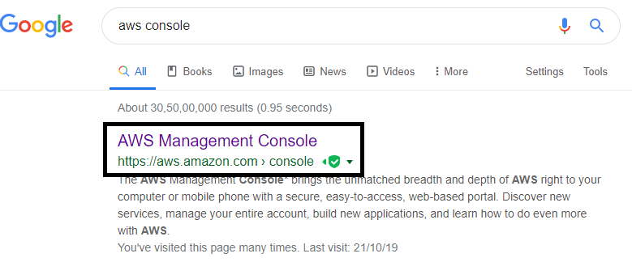

1. Double Click on Above link.

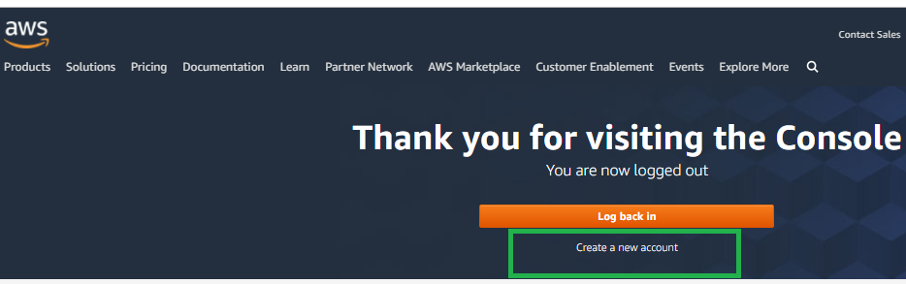

1. Click on “Create a new Account”

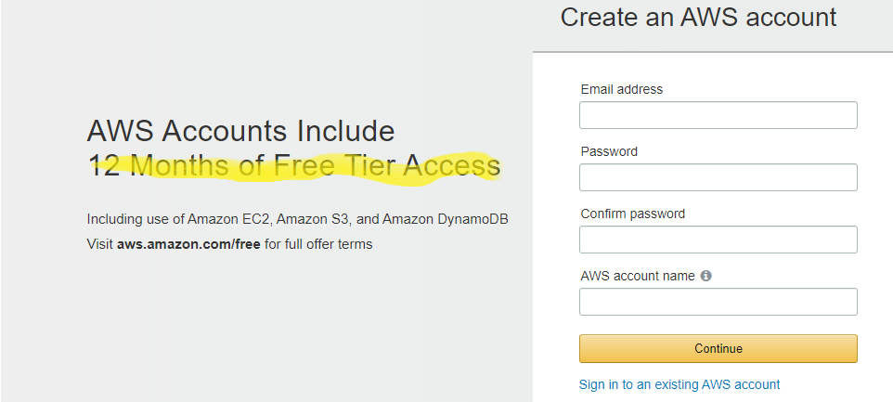

1. Fill above Fieldes and Click on Continue.

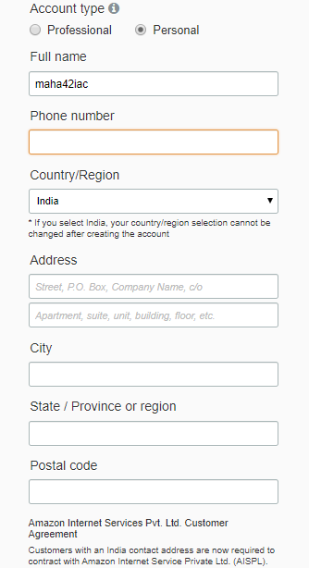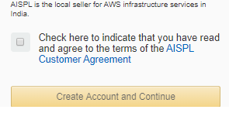

1. Fill above Fieldes and Click on “Create Account and Continue”.

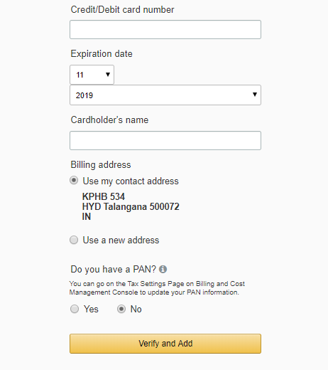

1. Fill above details with your credit / debit Card Details and click on “Verify and Add” and make payment success by providing OPT,

2 rupees will be detected and revert back from your account for verification.

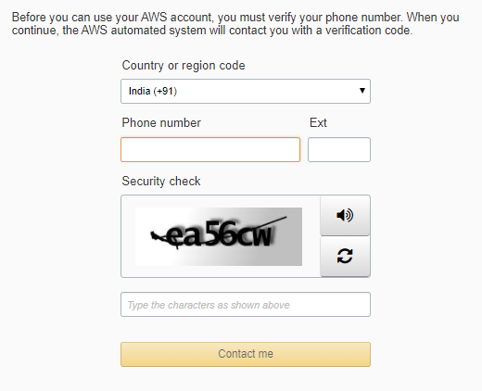

1. Provide your working phone number and security check, then click contact me. Then you will receive a call from AWS support.
2. Type 4-digit number in your phone pad, which is displaying on your pc screen.

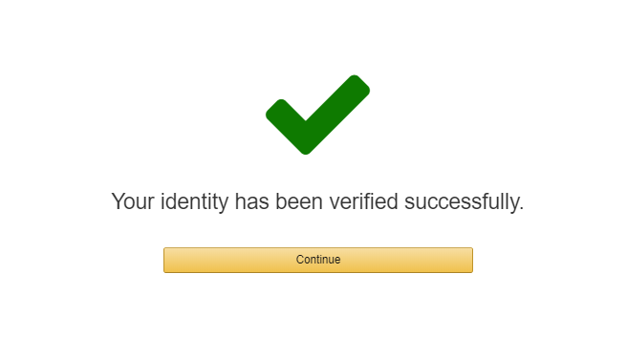

1. Click on Continue.

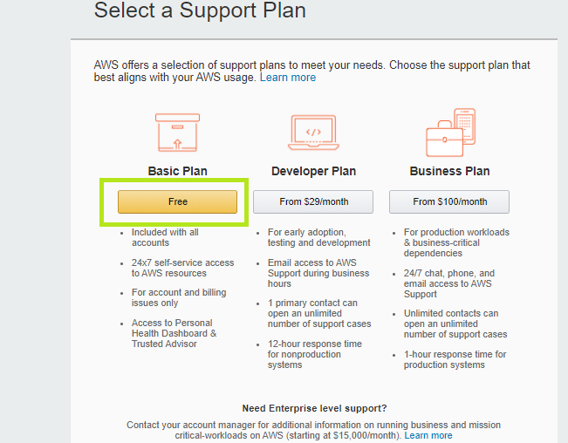

1. Choose basic plan. Your account creation completed.

Your account will be activated within 24 hrs. then you can able to logging by using “[https://aws.amazon.com](https://aws.amazon.com/)”

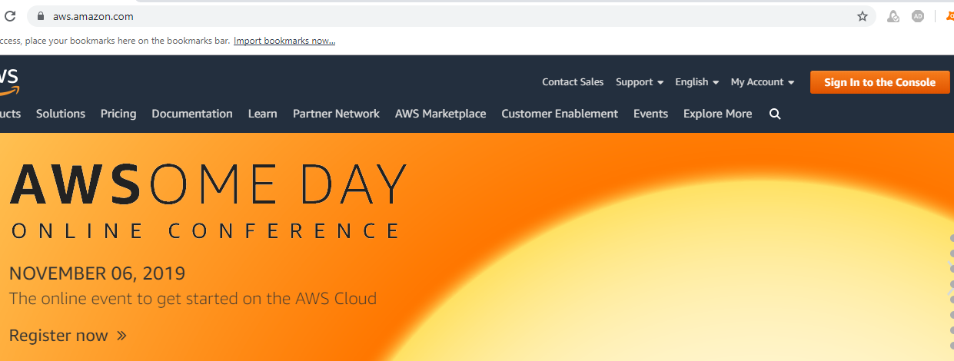

Click on sing in to console.

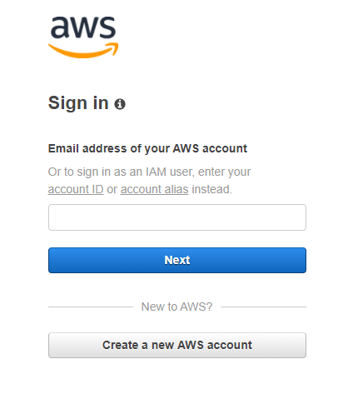

By providing user name and passwd, you can able to login and create AWS resources (Ec2 Instance, S3, VPC, RDS)

